# PROJECT IDENTITY

Project Title : Mobile Baby Monitoring System Application

Project Owner : Sandi Prasetyaningsih,S.T., M..Media

Project Manager : Agung Riyadi, S.Si. M.Kom

Project Co-Manager :-

Client : Agung Riyadi, S.Si. M.Kom

|  |  |
| --- | --- |
| ✓ | Final Report |
| ✓ | Product: *Mobile Application* |
| ✓ | Demo video /trailer* |
| ✓ | Scientific Poster |
| ✓ | Intellectual Property Rights Document |
| ✓ | Handover Document |
|  | Contest Proposal (optional) |

Outputs :

Group Member

Class: Teknologi Rekayasa Multimedia

1. 4312211059 - Chintya Nadya Salsa Billa
2. 4312211034 - Nurul Zalita Pratiwi
3. 4312211035 - Satria Setia Adhi
4. 4312211042 - M. Azhar Rezasyah Narayana
5. 4312211045 - M. Rafiq Raj Kumar

Approved by,

Batam, June 26 2024

Agung Riyadi, S.Si. M.Kom

NIK. 119221

# LIST OF CONTENT

PROJECT IDENTITY iii

LIST OF CONTENT v

LIST OF FIGURES vi

LIST OF TABLES vii

1. PROJECT-BASED LEARNING PRODUCT viii

1.1 Product Description viii

1.2 Product Design viii

2. PRODUCT IMPLEMENTATION ix

2.1 Product Implementation ix

3. CONCLUSION 1

2.1 Obstacle 1

2.2 Learning Process 1

APPENDIX I – LOGBOOK 2

APPENDIX II – TEAM SCHEDULE 3

APPENDIX III – PROJECT BOARD 4

APPENDIX IV – PRESENTATION SLIDES 5

APPENDIX … – …. 6

# LIST OF FIGURES

**Picture 1 Welcome Page vii**

**Picture 2 Home Page viii**

**Picture 3 Welcome Page ix**

**Picture 4 Home Page ix**

**Picture 5 Process PBL x**

# LIST OF TABLES

**Table 1 PBL Process** x

**DOCUMENT HISTORY**

Table 1 Dokumen History

|  |  |  |
| --- | --- | --- |
| **Date** | **Writer** | **Description** |
| 29 / 1 / 24 | All members | Creation of a pbl group with the project manager |
| 12 / 2 / 24 | All members | Understand and analyze project requirements (RPP) |
| 17 / 2 / 24 | All members | Met with mapro and discussed the creation of an IoT system-based application |
| 20 / 2 / 24 | All members | Collect data, what materials and equipment you want to use in this PBL |
| 29 / 2 / 24 | All members | Experiment with the tool with manpro. tools needed for this scale mobile application |
| 2 / 3 / 24 | chintya | flutter application creation with dart |
| 10 / 3 / 24 | chintya | splashscreen.dart creation on flutter |
| 16 / 3 / 24 | Azhar | Onboarding.dart creation on flutter |
| 21 / 3 / 24 | chintya | Creation of application logo |
| 24 / 3 / 24 | Nurul | UI/UX Desain |
| 01/ 4 / 24 | Azhar,Satria, Rafiq | IoT device connector |
| 22 / 4 / 24 | Chintya, Azhar | Running a test of the Arduino Lolin weighing sensor, IOT Device Programming |
| 03/5 / 24 | Nurul | Creating application use cases |
| 13 /6 / 24 | Satria | IOT assembly |
| 13 /6 / 24 | Chintya | connecting flutter with IOT via wifi manager |
| 21 / 6 / 24 | Nurul,Rafiq | Making PBL final report |
| 24 / 6 / 24 | Nurul | Manual Book |

**PROJECT WORK HISTORY**

Table 2 Project Work History

|  |  |  |
| --- | --- | --- |
| **Stages** | **Completion Date** | **The resulting output** |
| Planning | 15 – 22 February 2024 | Conduct the first meeting with the manpro, plan the budget, products, tools, and fill out the RPP |
| Planning | 22 – 23 February 2024 | Hold meetings between groups. Discuss and make a comprehensive list of tools to be purchased and used |
| Design | 26 – 28 February 2024 | Designing user interfaces, logos, colors and application names for mobile scales based on nationality |
| Analysis | 29 February – 2 March 2024 | meeting with manpro. discuss and practice directly, the tools that will be used later. for mobile ba we use Arduino-MCU Lolin V3 |
| Design | 4 – 8 March 2024 | Create and design UI Design. welcome page, star page, dashboard, automatic scale page. Adapt the design to the application you want to use. carry out UX design. |
| Implementation | 11 – 16 March 2024 | Assembling IoT devices, ensuring sensors are connected and lollin works, carrying out the process of implementing UI into Flutter |
| Implementation | 18 – 21 March 2024 | Make improvements to the sensor section, by making a sensor base (tray/container) at the top. Where the container will be made using cardboard which can support the weight of an object +- 10 kg. |

# PROJECT-BASED LEARNING PRODUCT

## Product Description

The Mobile Baby Monitoring System application is an innovative solution designed to give parents peace of mind when caring for their babies. The application allows users to monitor their baby in real-time via mobile devices such as smartphones, whenever and wherever they are.

A key feature of the application is its ability to display live video and detect movement from the baby's room. By using a camera connected to the application, users can clearly see what is happening in the baby's room, sound detection of the baby's cry by providing notifications to parents, humidity and temperature monitoring to ensure the baby's environmental conditions are comfortable.

## Product Design

Product design for a mobile application project should have the following design:

* 1. **General system description.**

The Mobile Baby Monitoring System application is an integration between a mobile application and an IoT system. The idea is a smart crib system that will help parents monitor their babies remotely. This idea comes with a cry detection mechanism, live video surveillance, cloud computing data and user interface in the mobile version.

1. Components and Tools
2. Hardwares:

* NodeMCU ESP8266: A microcontroller that acts as the central controller, collecting data from sensors and sending it to the mobile application.
* Sound Sensor (KY-037): Detects baby sounds or crying.
* Motion Sensor (PIR Sensor): Detects the baby's movements.
* Temperature Sensor (DHT11 or DHT22): Measures the temperature of the environment where the baby sleeps.
* Breadboard and Jumper Cables: For connecting the sensors to the ESP8266.
* USB Cable: For connecting the NodeMCU to a laptop for programming and power.

1. Softwares:
   * + - Arduino IDE: Used for writing and uploading code to the NodeMCU ESP8266.
       - Android Studio: Used for developing the mobile application.
       - Flutter and Dart: Flutter is the UI toolkit used to build natively compiled applications for mobile from a single codebase, and Dart is the programming language used to write the application code. This combination ensures a smooth and efficient development process for creating a responsive and attractive mobile application.
   1. **Functional system requirements**
2. The app can provide real-time notifications to parents of significant changes in the baby's environment, such as crying or unusual movements.
3. The application can connect to a cloud server for secure data storage, accessible from anywhere.
4. The application can receive data from sound, motion, temperature, and humidity sensors.
   1. **Use Case**

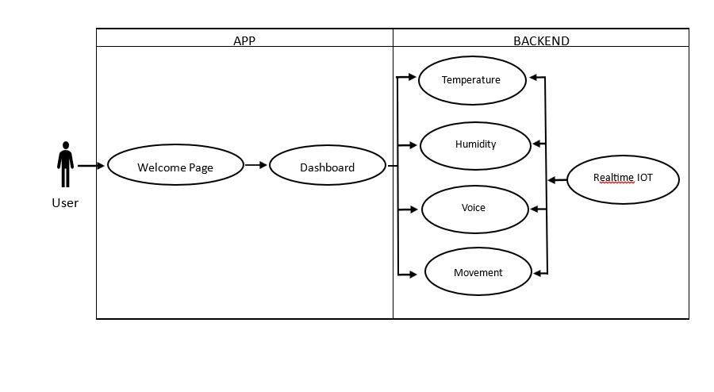

* 1. Programming language.

The programming language we use in this mobile baby monitoring application is as follows:

1. **Flutter(Dart)**

Flutter is an open-source framework developed by Google to build mobile, web, and desktop applications with a single code base using the Dart language.

baby monitoring applications, Flutter offers several advantages. High performance and the "hot reload" feature speed up the development and debugging process.

1. **Arduino application**

Arduino is a very popular open-source platform for hardware development involving sensors and microcontrollers. arduino's role in this pbl is Sensor Data Collection, Data Processing and Transmission.

1. **Android Studio**

Android Studio is the official integrated development environment (IDE) for Android app development. In the context of baby monitoring apps, Android Studio offers very useful tools and features for building feature-rich and responsive apps.

# PRODUCT IMPLEMENTATION

## Product Implementation

Product implementation for mobile application projects:

1. Implementation for user interface / product design.

Application Architecture

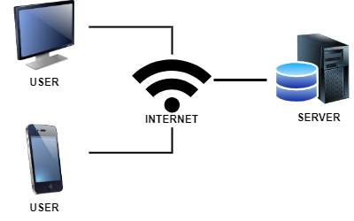

The image above is the application architecture design for a mobile baby monitoring system. Where users can access websites using the internet network so they will be connected to this mobile baby monitoring system (cloud baby) server.

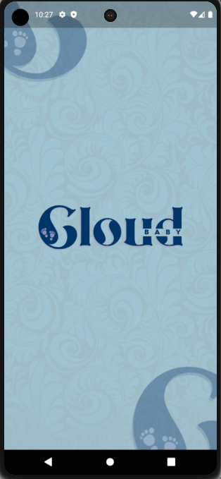

Splashscreen page

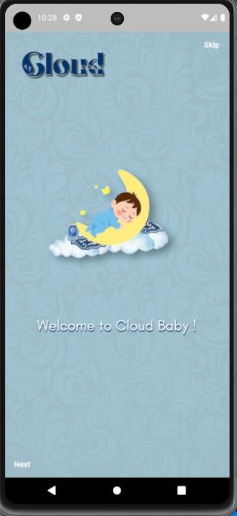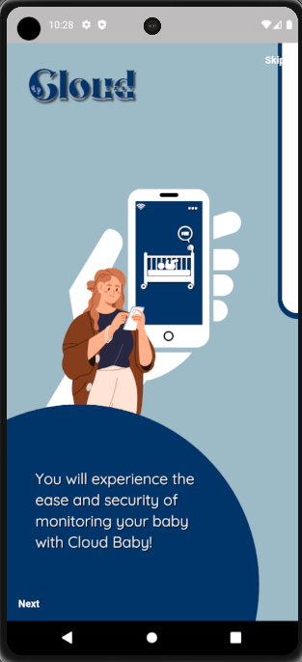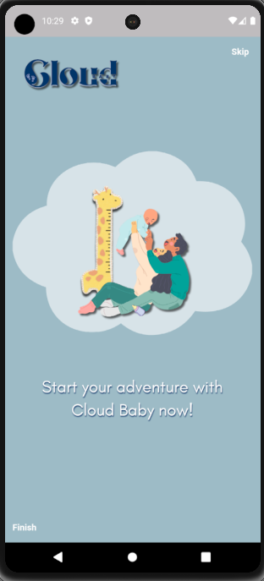

Onboarding Page

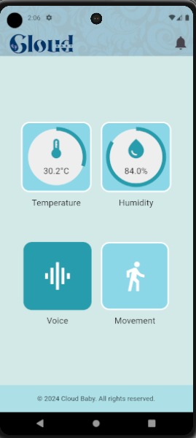

Main Page

1. Product testing result.

|  |  |
| --- | --- |
| Step 1 | Step 2 |

Picture 5 Process PBL

Source: Personal Document

Table 3 Product Testing

Table 1 PBL Process

|  |  |
| --- | --- |
| Steps | Process |
| Step 1 | Discussing the planning with the out project manager and team |
| Step 2 | Start assembling for IoT components are needed for baby monitoring |

# CONCLUSION

## 2.1 Obstacle

During the application mobile project, we faced some problems both technically and internally. Technically, there were several programs that did not run according to our expectations, however. Internally, there were also some conflicts of opinion on the concept of our website. But with various revisions and discussions, we managed to get through these problems. For the project, we will finish on target because the obstacles we face are not so many and can be overcome so that the project work is completed on target

## 2.2 Learning Process

Participating in the PBL project provided many new insights and valuable learning experiences. One of the most memorable aspects was gaining practical experience in developing an IoT-based mobile application from start to finish. This included an understanding of hardware components such as sensors and microcontrollers, as well as software aspects involving the use of the Flutter framework and Dart language for Android development.

In addition, this project provides an in-depth understanding of the complexities of integrating various technologies to create a whole system. Understanding how to organize communication between various devices and ensure efficient data transmission and processing were important aspects that I learned during this project.

In relation to the courses taken this semester, we found that concepts from courses such as Software Engineering, IoT Systems, and Mobile Application Development were very relevant to this project. The concepts learned in the Software Engineering course, such as requirements analysis, system design, and testing methodologies, are essential to effectively plan and execute the project. Likewise, knowledge from the IoT Systems course helped in understanding the basic principles of IoT architecture and sensor integration. Lastly, the Mobile Application Development course provides the necessary skills to develop user interfaces and fun

Overall, working on the PBL project provided a comprehensive learning experience that reinforced and applied the theoretical knowledge gained from the course, allowing me to face real challenges in developing IoT-based mobile applications.

# APPENDIX I – LOGBOOK

Put your logbook from SIAP-PBL in here

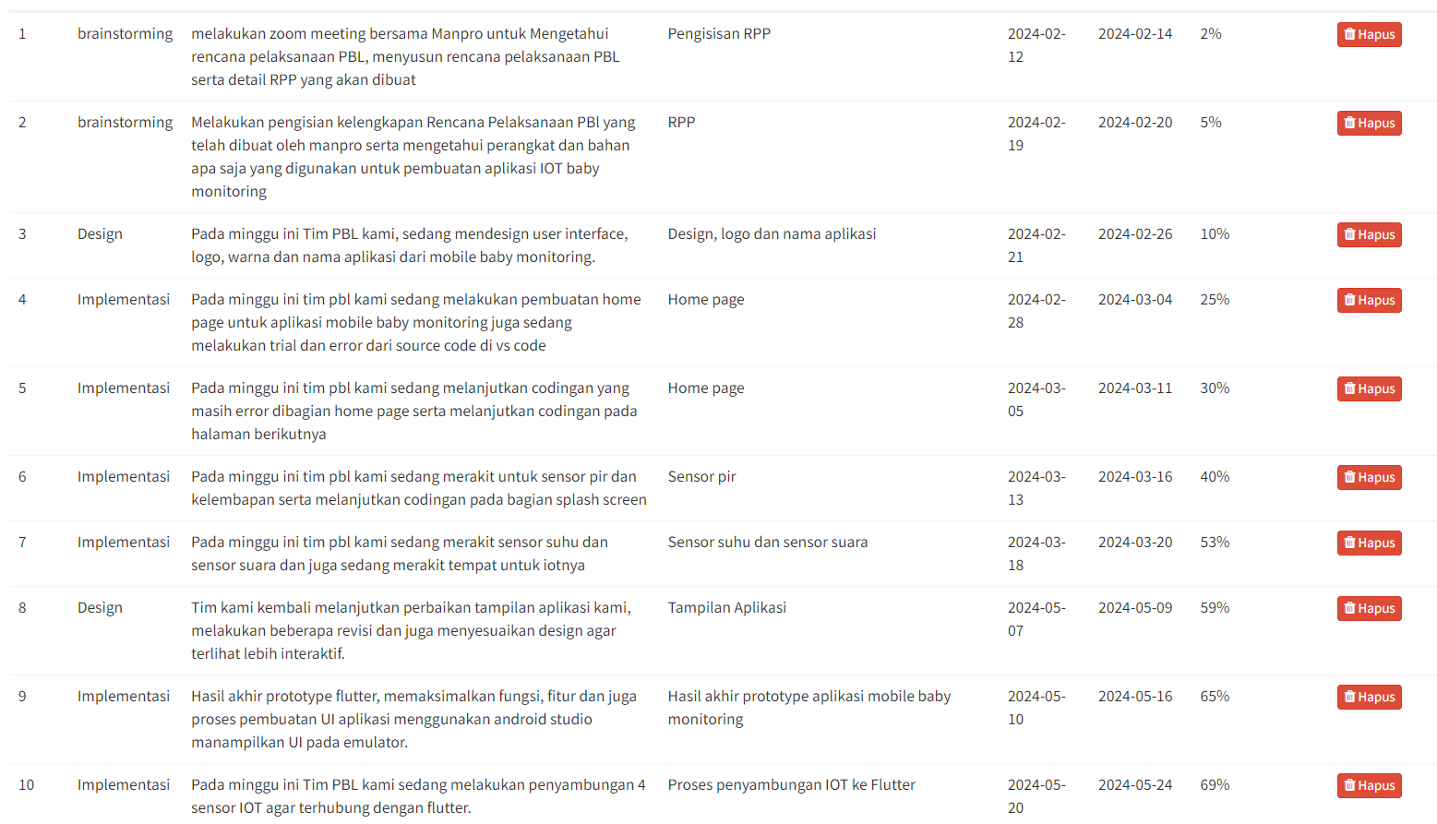

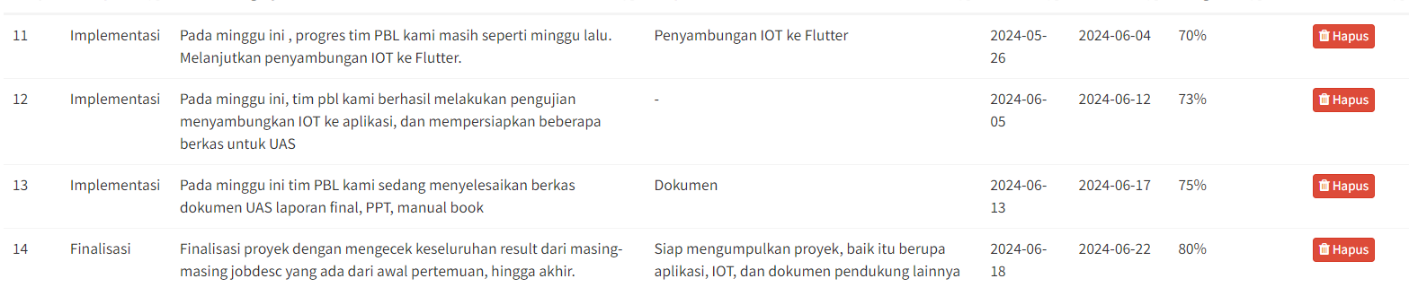

# APPENDIX II – PRESENTATION SLIDES

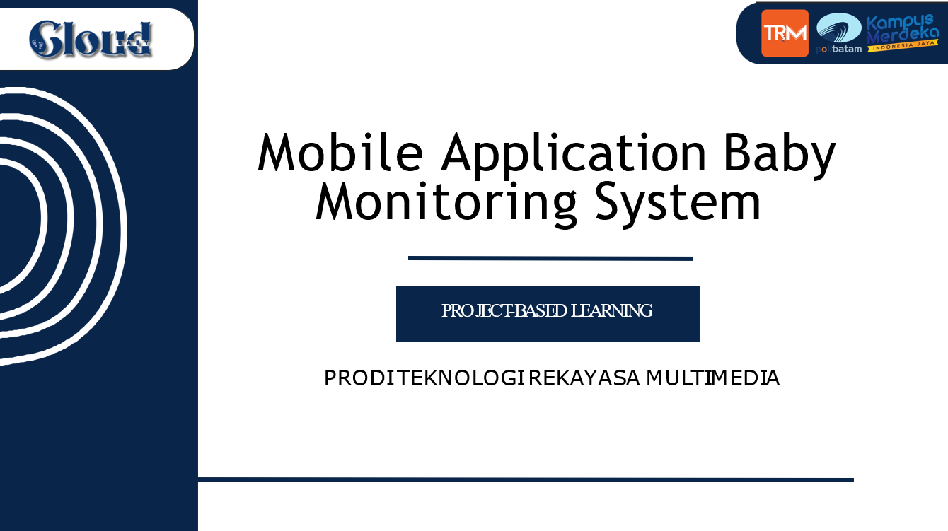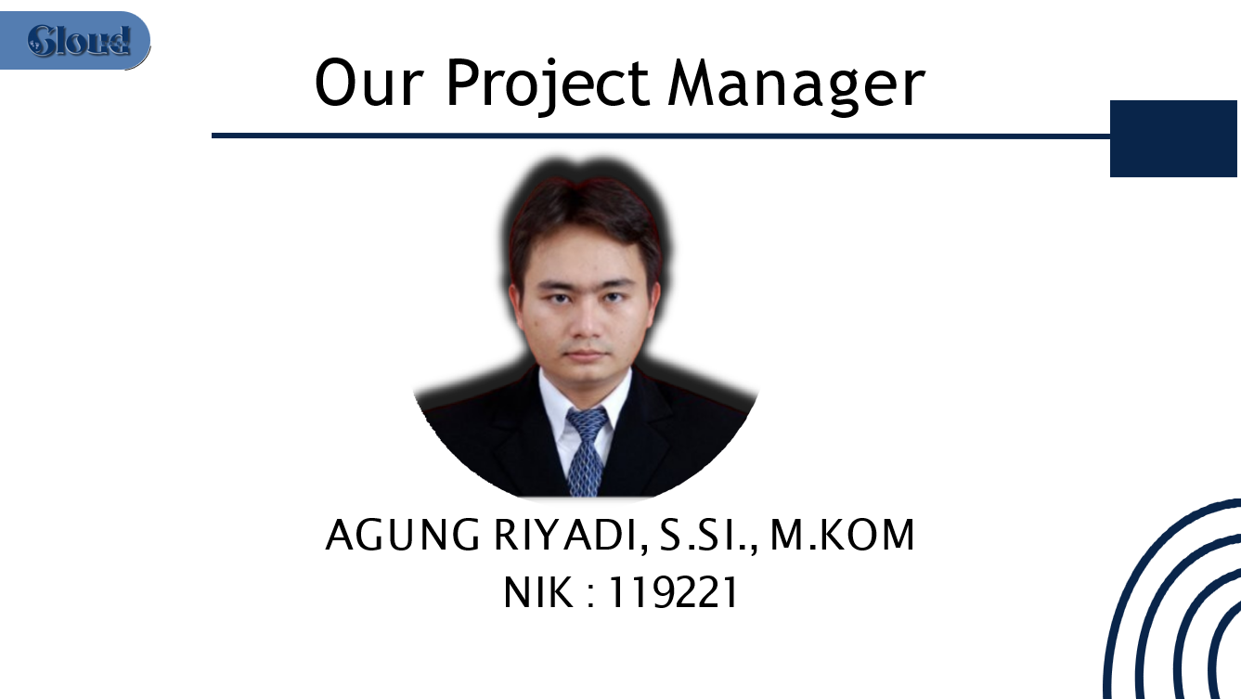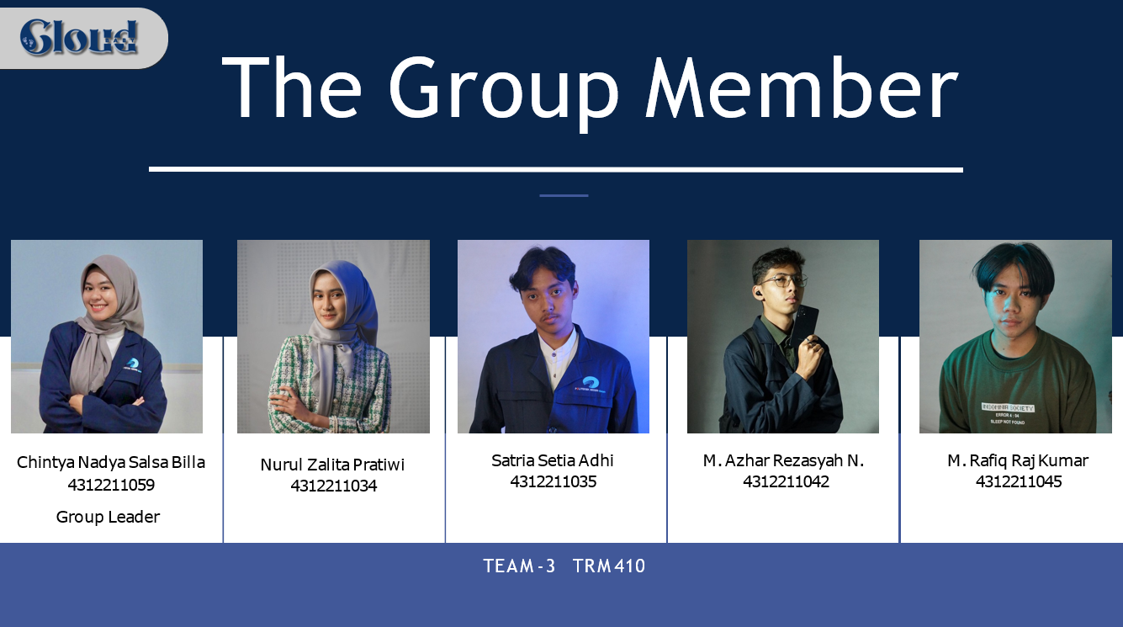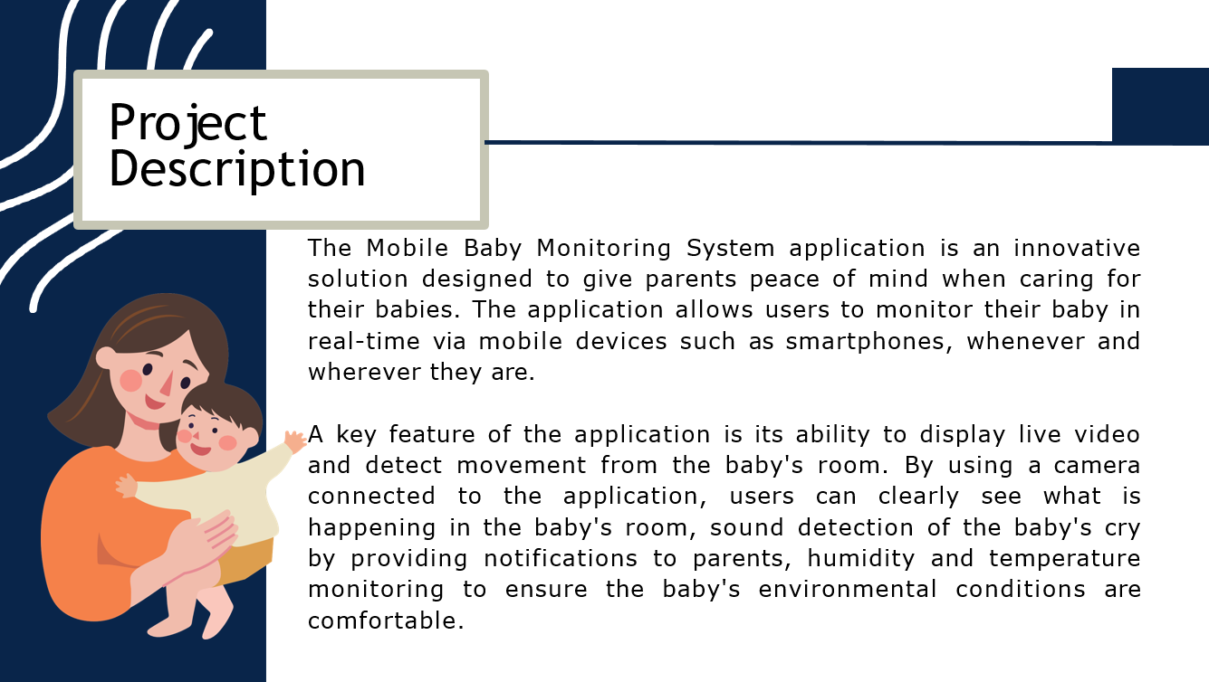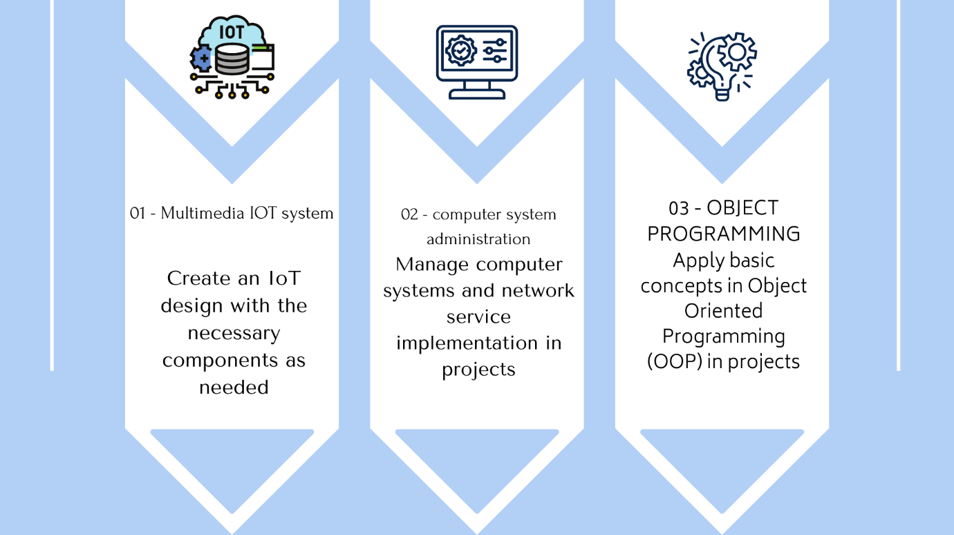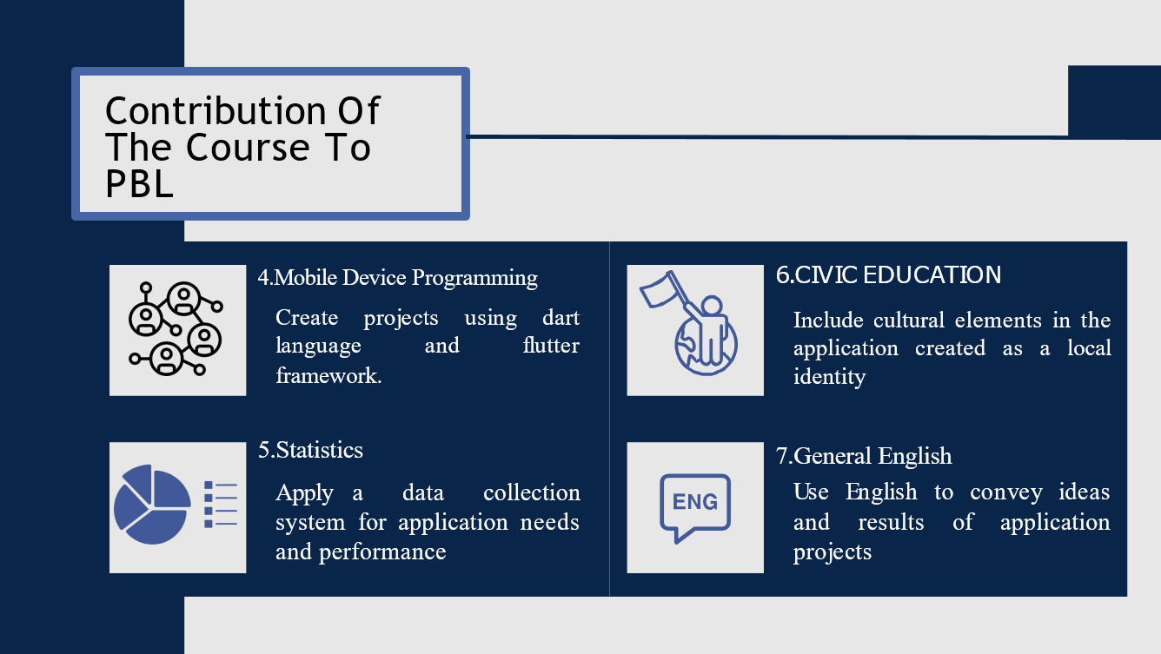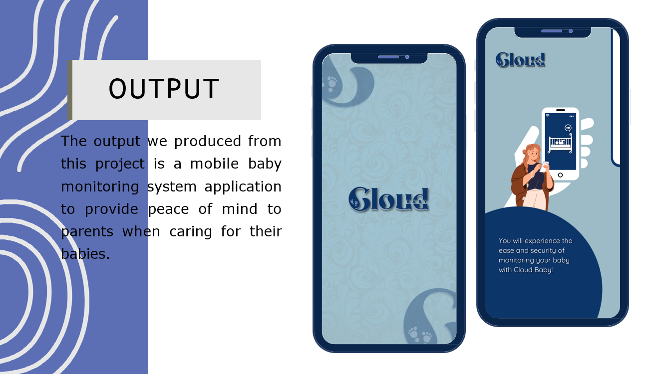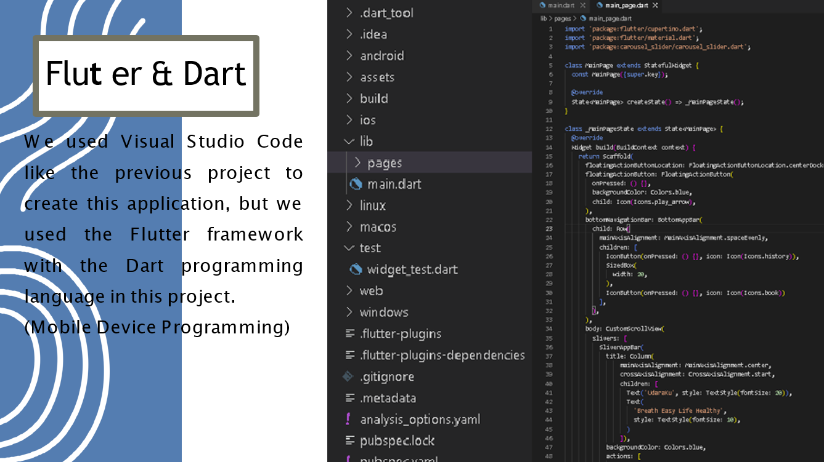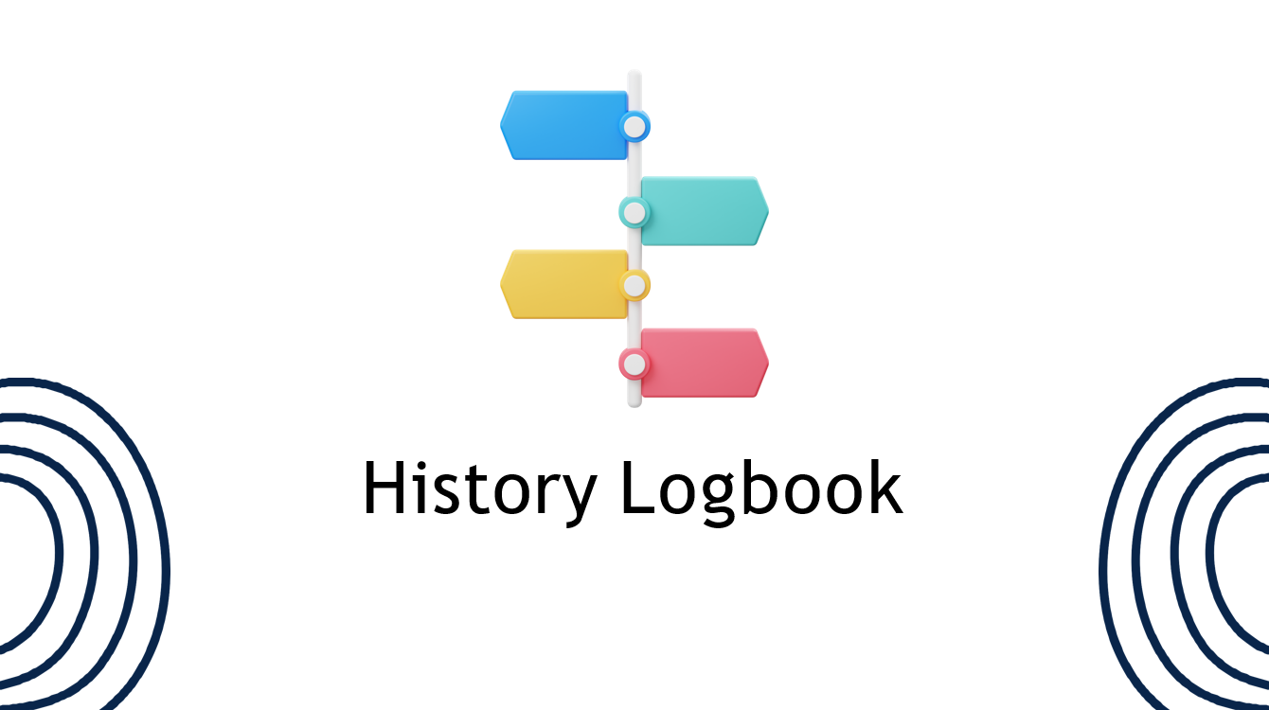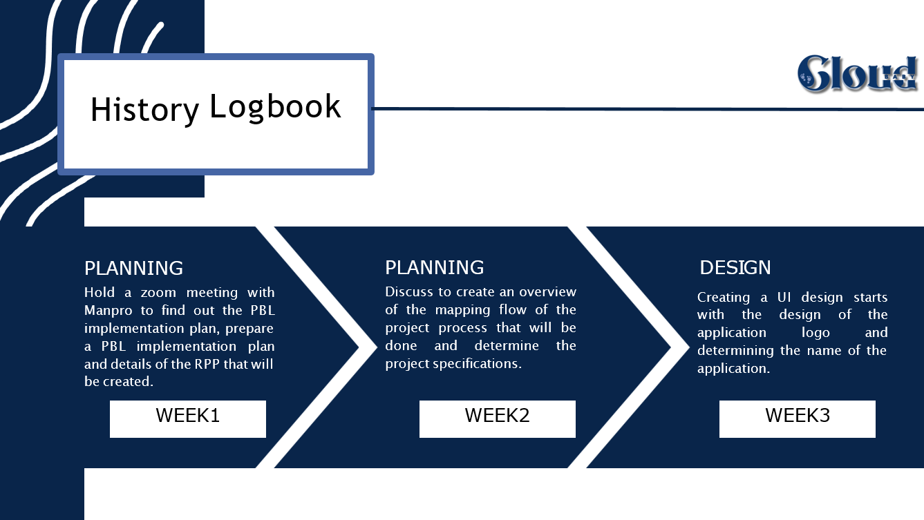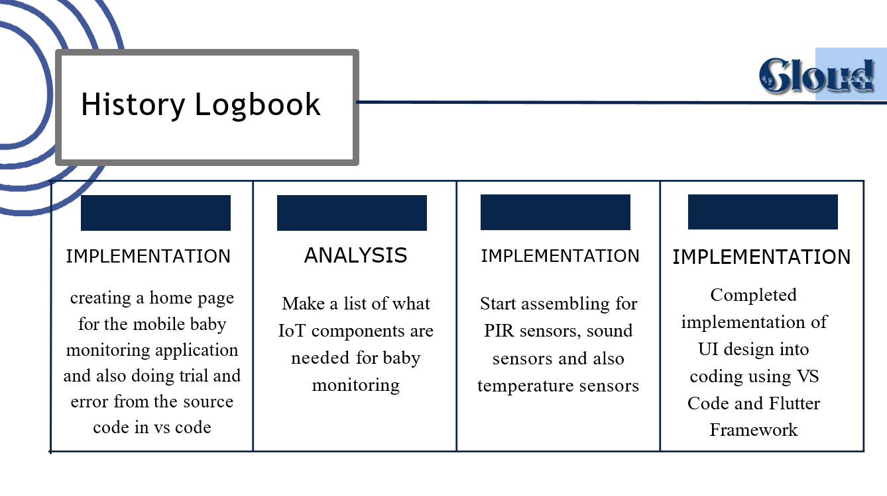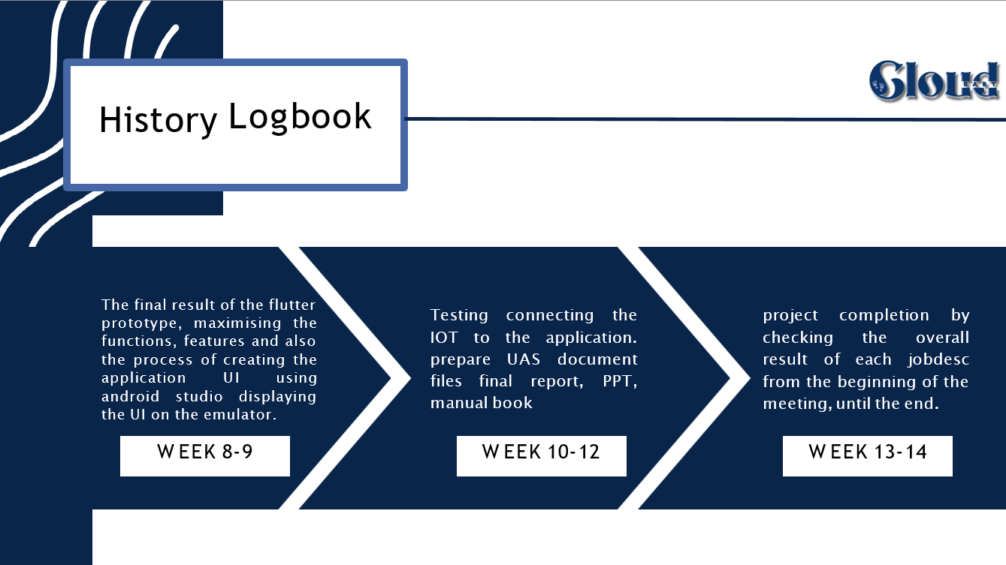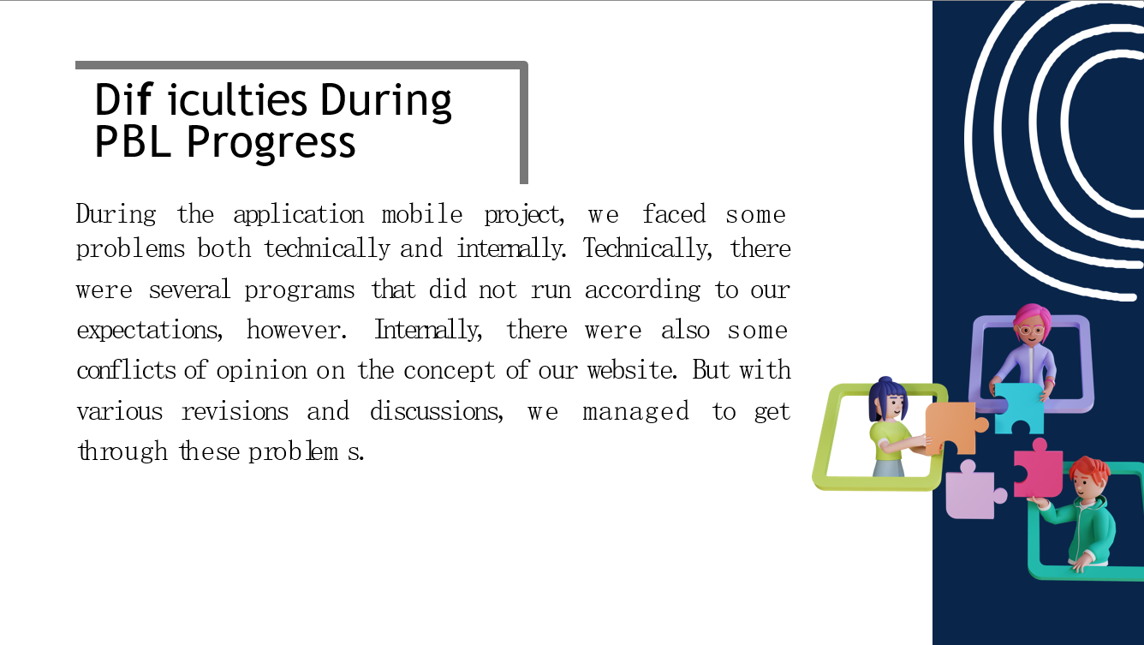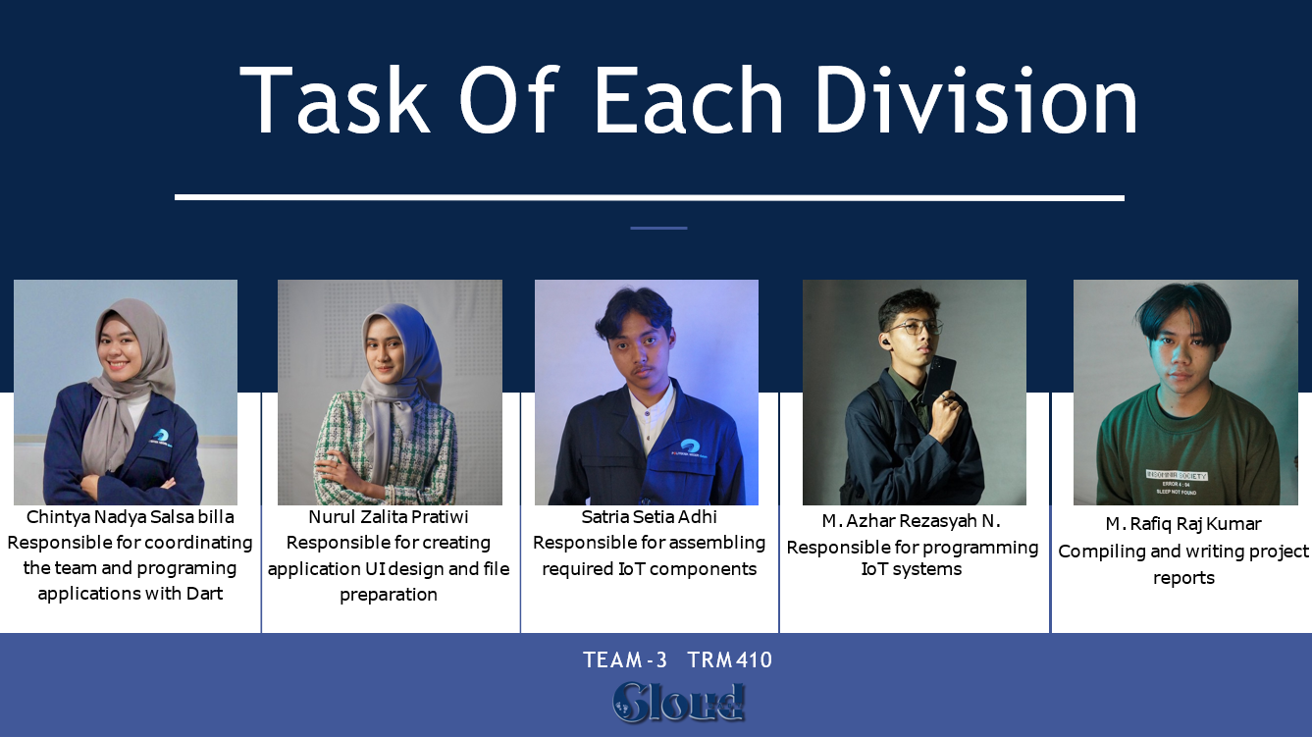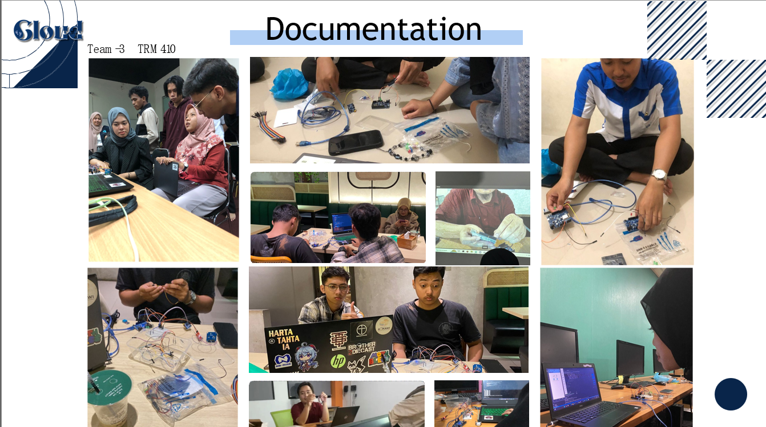

# APPENDIX … – ….

You can add appendices as needed such as:

1. Link of product

:-

1. Link of presentation

:

1. Link of demo video /teaser

:-

1. Link of scientific poster

:-

1. Link of Intellectual Property Rights Documen

:-

1. Link of handover document scan

:-

1. Link of contest proposal (optional)

:-

Make sure the link provided is set up to be accessible to the **public.**

s

